

***SMART STREET LIGHT PROJECT***

**A STEP INTO THE FUTURE**



GALGOTIAS UNIVERSIY

**GROUP MEMBERS**

**HARSH BHARDWAJ-23SCSE1410069**

**SUMIT KUMAR VERMA-23SCSE1410063**

**VANSH LATIYAN-23SCSE1410026**

**MD-FARHAN AKHTAR-23SCSE1410082**

**SACHIN KUMAR-23SCSE1410066**

**SUBMITTED TO- DR.ROOPALI SHARMA**

**INTRODUCTION**

**Introduction to the Smart Street Light Project**

**The Smart Street Light Project is an innovative initiative aimed at transforming traditional street lighting systems into an intelligent network that enhances energy efficiency, reduces operational costs, and improves urban safety and sustainability. This project leverages advanced technologies such as Internet of Things) sensors, and automation to create a responsive and adaptive lighting infrastructure.**

### **Objectives of the Project**

1. **Energy Efficiency: Implement energy-saving measures by adjusting the brightness of street lights based on real-time conditions, such as traffic flow and pedestrian presence.**
2. **Cost Reduction: Lower maintenance and operational costs through automated monitoring and fault detection systems**
3. **Environmental Impact: Reduce carbon footprint by optimizing energy usage and incorporating renewable energy sources where possible.**
4. **Data Collection: Gather valuable data on urban mobility patterns, environmental conditions, and infrastructure usage to inform future urban planning and development.**

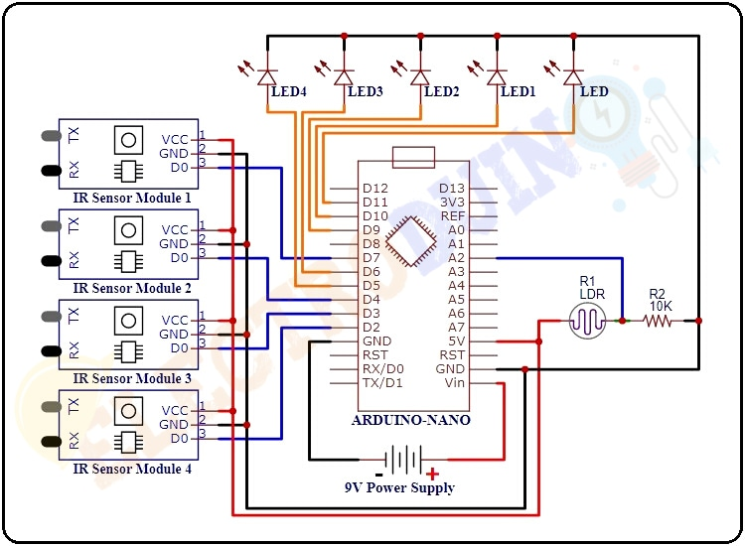

**KEY FEATURES**

* **Adaptive Lighting**: Street lights automatically adjust their brightness based on the surrounding environment, time of day, and weather conditions.
* **Remote Monitoring**: Centralized control systems allow for remote monitoring and management of street lights, enabling quick response to faults and maintenance needs.
* **Motion Sensors**: Lights are equipped with motion sensors to detect the presence of vehicles and pedestrians, ensuring lights are only at full brightness when needed.
* **Solar Power Integration**: Some street lights are equipped with solar panels to harness renewable energy, further reducing dependency on the grid.
* **Data Analytics**: The system collects and analyzes data to optimize performance, predict maintenance needs, and support smart city initiatives.

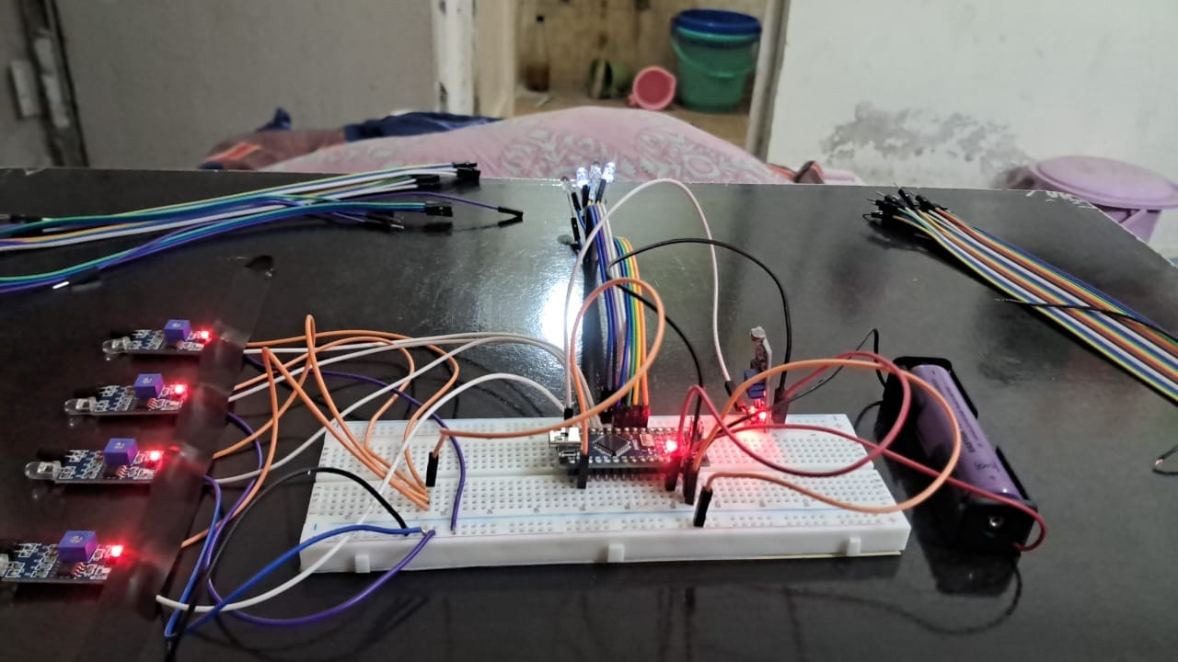

**FLOW CHART**

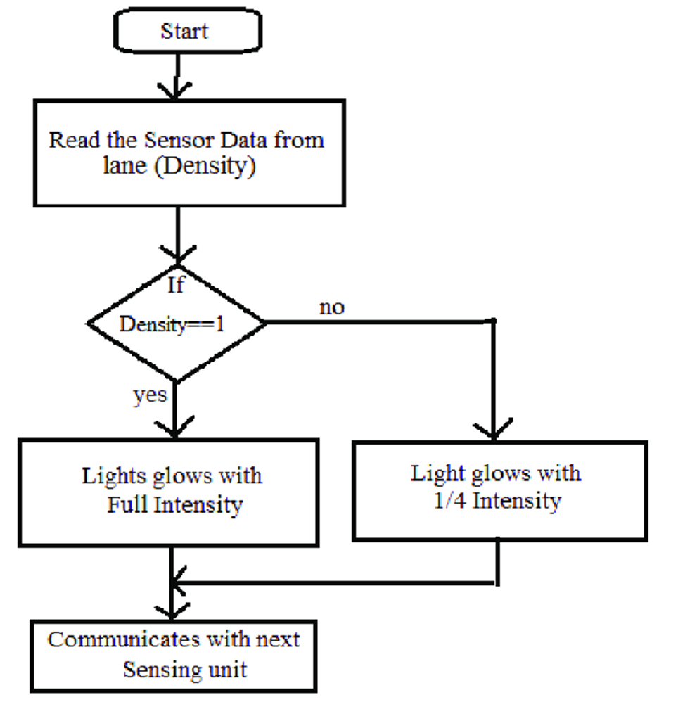

**WORKING OF THE MODEL**

### Working of the Smart Street Light Project

The Smart Street Light Project integrates several advanced components, including a controller chip, LEDs, solar panel, battery, and IR sensors, to create an intelligent and energy-efficient lighting system. Here's how these components work together:

1. **Controller Chip**:
   * **Central Hub**: The controller chip acts as the central processing unit for the smart street light system.
   * **Coordination**: It coordinates the functions of all other components, ensuring they work harmoniously.
   * **Data Processing**: It processes data received from the IR sensors and other inputs to make decisions on lighting levels.
   * **Communication**: The chip may also communicate with a central control system for remote monitoring and management.
2. **LEDs (Light Emitting Diodes)**:
   * **Efficient Lighting**: LEDs are energy-efficient light sources that offer long-lasting and bright illumination.
   * **Adjustable Brightness**: The brightness of the LEDs is controlled by the controller chip, which can dim or brighten the lights based on real-time conditions.
   * **Durability**: LEDs are durable and require less maintenance compared to traditional bulbs.
3. **Solar Panel**:
   * **Energy Source**: The solar panel captures sunlight during the day and converts it into electrical energy.
   * **Sustainability**: This harnesses renewable energy, reducing reliance on the electrical grid and minimizing environmental impact.
   * **Energy Storage**: The generated electricity is used to charge the battery for nighttime use.
4. **Battery**:
   * **Energy Storage**: The battery stores the electricity generated by the solar panel.
   * **Power Supply**: It provides power to the LEDs and the controller chip during the night or in low-light conditions.
   * **Backup**: The battery ensures continuous operation even during periods without sunlight.
5. **IR Sensors (Infrared Sensors)**:
   * **Motion Detection**: IR sensors detect the presence of pedestrians and vehicles by sensing their heat signatures.
   * **Dynamic Lighting**: When motion is detected, the sensors send signals to the controller chip to increase the brightness of the LEDs.
   * **Energy Saving**: In the absence of motion, the lights dim to a lower level to save energy while maintaining basic visibility.

### Operational Workflow

1. **Daytime Operation**:
   * The solar panel captures sunlight and converts it to electrical energy.
   * The energy is stored in the battery while the controller chip remains in low-power mode.
   * The LEDs are off or in a very dim state, conserving energy.
2. **Evening and Night time Operation**:
   * As the sun sets, the controller chip switches to night time mode, drawing power from the battery.
   * LEDs provide illumination based on predefined levels or ambient light sensors.
3. **Adaptive Lighting**:
   * When an IR sensor detects motion, it signals the controller chip to increase the brightness of the LEDs in that specific area.
   * The lights remain bright as long as motion is detected.
   * Once motion ceases, after a set period, the LEDs dim to a lower level to save energy.
4. **Remote Monitoring and Control**:
   * The controller chip can communicate with a central management system, allowing for remote adjustments, monitoring of performance, and fault detection.
   * Data collected can be used for maintenance scheduling and performance optimization.

### Benefits and Outcomes

* **Energy Efficiency**: Maximizes energy savings by using solar power and adjusting brightness based on real-time needs.
* **Cost Reduction**: Lowers operational and maintenance costs through automation and durable components.
* **Enhanced Safety**: Provides adequate lighting when and where needed, improving safety for pedestrians and drivers.
* **Environmental Impact**: Reduces carbon footprint through the use of renewable energy and efficient lighting technologies.
* **Smart City Integration**: Contributes valuable data for broader urban planning and smart city initiatives.

By combining these technologies, the Smart Street Light Project creates a sustainable, cost-effective, and intelligent lighting solution for modern urban environments.

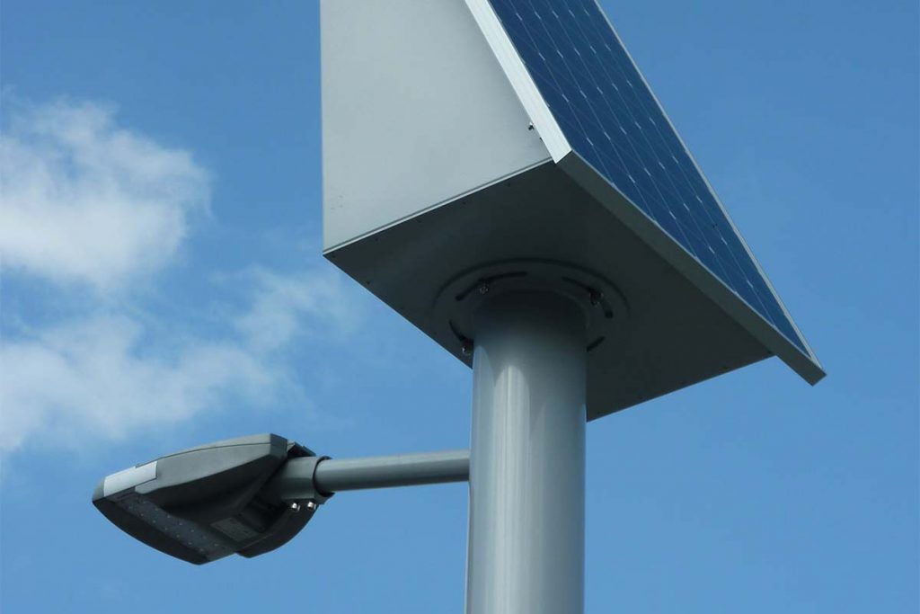

**CONCLUSION**

The Smart Street Light Project represents a transformative approach to urban lighting, merging technological innovation with sustainability. By providing a blueprint for intelligent, responsive, and eco-friendly street lighting, this project sets a precedent for future smart city initiatives. The benefits of reduced energy consumption, improved safety, environmental conservation, and enhanced urban management collectively demonstrate the project's profound impact on modern urban living.

In conclusion, the Smart Street Light Project is a testament to the potential of integrating advanced technologies with traditional infrastructure. It highlights the importance of innovation in creating smarter, safer, and more sustainable cities, paving the way for a brighter and more efficient urban future.

**####REFERENCE####**

***-Indore municipal corporation***

***-zgsm_china.com***

***-electroduino.com***

***-GPT(for hardware related knowledge)***

***-etc………***

***LINK OF WORKING MODEL***

***:-*** ***https://youtu.be/H1lmOqHZh2E?si=q2jZ5wY9CEkmVyIx***

**Team Members Contribution**

|  |  |  |
| --- | --- | --- |
| ***NAME*** | ***ID*** | ***CONTRIBUTION*** |
| Harsh Bhardwaj | 23SCSE1410069 | All PPT-Report & Codding |
| Sumit kumar verma | 23SCSE1410063 | Coding & Quality Check |
| Sachin Kumar | 23SCSE1410066 | Connections done & Check |
| Vansh Latiyan | 23SCSE1410026 | Assembly done & Check |
| MD.Farhan Akhtar | 23SCSE1410082 | Idea & Design |

***THANK***

***YOU***